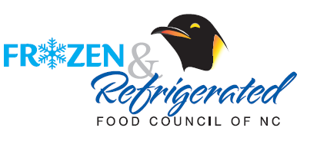

The mission of the Frozen & Refrigerated Food Council of NC is to support retailers and manufacturers in the Southeast by increasing sales and educating the consumer about refrigerated and frozen foods.

The Council is THE local organization unifying brokers, manufacturers, and retailers in the common goal of increasing the consumer sales of frozen and refrigerated foods.  Through communications via [www.carolinacoolfoods.com](http://www.carolinacoolfoods.com) and informational member emails, members are made aware of the latest industry news and selling opportunities.  Council meetings foster important opportunities for colleagues and competitors to learn and share timely information that helps everyone stay ahead in the game.

Most importantly, the vast number of Carolina retailers strongly support Council programs.  We work with the category managers of the top retailers 3-5 times yearly to provide effective sales-generating programs.  These retailers recognize the importance, especially in this competitive environment, of promoting refrigerated and frozen products in unison to the consumers.

The Council is 400+ members strong.  Member companies are strong advocates and the driving force in Council marketing events, quarterly meetings, and the McKenney Golf Classic.  Your participation is key whether a Retailer, Wholesaler, CPG company, Sales Agent, Marketing Company or Supplier…….

**Please join us this year and years to come to create and sustain a profitable, competitive Southeast market.**

**For more information contact:**

Joe D’Alberto Cathy Crump or Jill Porter

Frozen & Refrigerated Food Council of NC Advanced Marketing, Inc.

704.227.7447 704.548.0119

[jdalberto@acosta.com](mailto:jdalberto@acosta.com) [cwcrump@carolina.rr.com](mailto:cwcrump@carolina.rr.com)

[jillporter@carolina.rr.com](mailto:jillporter@carolina.rr.com)

**[](http://www.kjsmarket.com/)**